Mac Software Update Process

May 20, 2016

# Initial Configuration

As part of the standardization process, Centrify is installed, and the device is bound to Active Directory. Thereafter, every hour, when on the TE network, Centrify will apply a set of policies based on the Active Directory group the device is present in (hereafter referenced as “Group Policy” or “GPO”). As part of GPO, the device will be prompted to check the Mac App Store (hereafter referenced as “MAS”) for any available software updates.

# Notifications that updates are available

Should the Apple Software Update process (hereafter referenced as “ASU”) identify any available updates, a notification window is displayed.

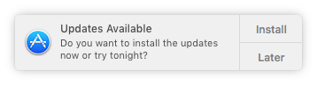

The “Install” choice will immediately begin downloading the updates. Once downloaded, installation of any update that does not require a reboot begins. If the installation of any updates would prompt for a reboot, an additional notification is provided prior to installation.

The “later” choice provides various options relating to deferring the updates.

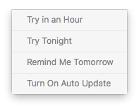

* “Try in an Hour” – All updates are suppressed for 60 minutes, with a new notification presented thereafter.
* “Try Tonight” – The update will attempt to be executed between 2 AM and 5 AM (local time), including executing any needed reboots. If the device includes the “Power Nap” feature, it will wake from sleep in order to attempt these updates.
* “Remind Me Tomorrow” – All updates are suppressed for 24 hours, with a new notification presented thereafter.
* “Turn On Auto Update” – Sets an option for future updates, that do not require a reboot, to be installed automatically, without any prompting from the user.

# Software Update Options

In addition to the automated process outlined above, the ASU process can be accessed manually through the Mac App Store application. MAS can be accessed either through its icon in the Applications menu, or from the “App Store…” entry in the Apple menu.

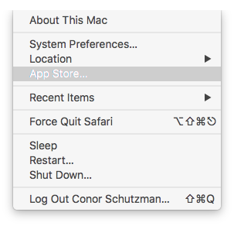

The “Updates” pane of the MAS provides a list of all available updates, with installation buttons.

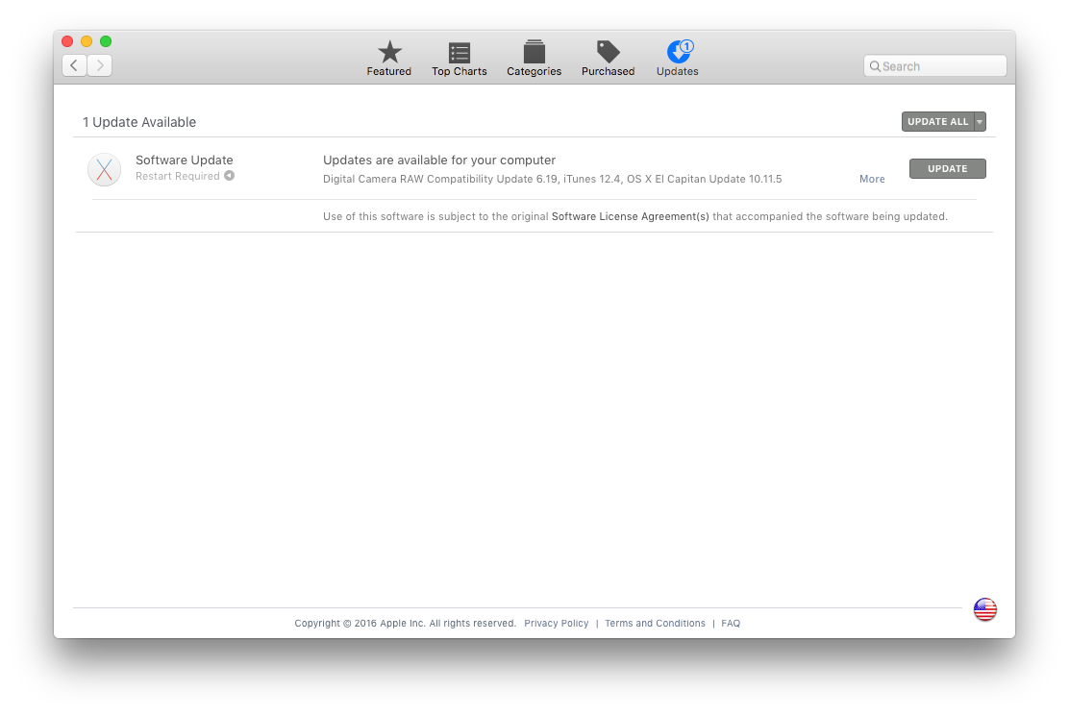

Additional customization of the Software Update process can be edited using the “App Store” pane of System Preferences. The “Automatically check for updates” check box will be automatically set active each time that GPO executes on the device. Additional options are provided to automatically install either OS X updates, or updates to Apps purchased through MAS.

